(6) Try the following script and fix the errors!
#!/bin/bash
echo "Input a number: "
read n
if [[ "$n" -gt 100 ); then
echo "The number is greater than 100."
else
echo "The number is not greater than 100."
fi
if [[ "$n" -gt 100 }] then
echo "The number is greater than 100."
fi

Corrections:
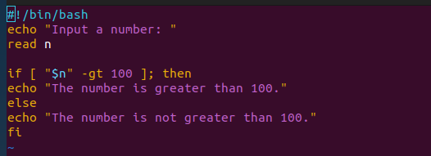

7.Debug the following script:
#!/bin/bash
# Getting the username of the logged-in user
logged_in_user=$(whoami)
# Checking if the user is logged in
if [ -n "$loged_in_user" );
then
echo "The logged-in user is: $logged-in_USER"
else
echo "User is not logged in"
fi

Corrections:
